Strayer University

INVENTORY MANAGEMENT SYSTEMS

Week 2

Assignment 1

for the

Course of

Systems Analysis And Development

4/17/2017

By

Kennedy Kabaso.

Proffesor: Hoskins.

**INVENTORY MANAGEMENT SYSTEMS**

**Introduction**

Last year, I went to see my Mother whom I had not seen for fifteen year in Africa. It was one of my most memorable momet in my life. I had to fly for fourteen hour which was one of my longest flight I have ever had. I was kind of scared because we were on the ocean for twelve hours. I was very happy to be there which made my famiy to have a big dinner. During a dinner, my sister Veronica, who has a small clothing store express her frustration about having to manually track and reorder items which were on high demand. She told me if I could create a plan for a low-cost automated inventory system which can meet her small budget. I told her I would try my best by using all the best computer skills I have to solve her problem.

Therefore, am going to describe the whole process and all the necessary equipment which are required, explain the costs involved in the creation of the system, describe the on going maintenance that will be required and finally provide a workflow diagram in Visio or equivalent software to illustrate how the system will work.

**Necessary Equipment**

The most impatantant issue was her budget which is very small, therefore I wanted her to get an automated system IQRF. IQRF Automated Inventory System which is a wireless communication system for localization, data collection and control for use in the industrial sphere, stores, shops or other places, a laptop used to see all her data in the database, internet service with a wireless router which is used to comunicate to the whole world and to the equipment that uses wireless and software used to help with the inventory system . Any cheap software which keeping track of sales order, customers, inventory, purchasing and reports can work well. Moreover, updates can be done automatically which makes it better if you have the wireless internet. The IQRF track the position and movement of objects within a given space using IQRF smart transceivers. IQRF transceivers are very powerful identification units which work as a two directional wireless communicators. It makes the whole system to be acted by a superior units which make sure all the objects are kept safe.

**Costs**

The most impontant job of the IQRF Automated Inventory System is to take inventory of goods, components, vehicles and other items in a particular space without handwork. Automated methods are much faster and cheaper, while IQRF wireless technology which is built into it makes the equipment more flexible and efficient. This can reduce the cost of paying someone to monitored it. In additional, It collects data such as change of an object's position, access to an object, status of an object and some important information about the inventorry of things. IQRF transceivers can takecare of inventoried things and process data which was taken if query. The whole process reduce the work force which is good for the business which can results in more saving which can be pumped into the business. The whole budgets can be some few thousand of dollers which she can affordable to her.

**Maintenance**

The maintenance of this equipment is something she doesn't have to worry about as it comes with life warrant. The lapetop can be restore to a factoy level if it stops working properly. The only thing she needs to keep is the CDs which comes with the software for the invetory. She also have to take the inventory system training and buying the package for technical support. This will save her money because she does n't need an information technology personal to do that. The equipments for the internet is taken care of by the internet service provider. Once it stop working,they would replace with a knew one without a cost.The maintenance cost can be put on her training cost which is $150.

Finally, the whole process if well done would produce better results for her small business.

**Flow Chart**

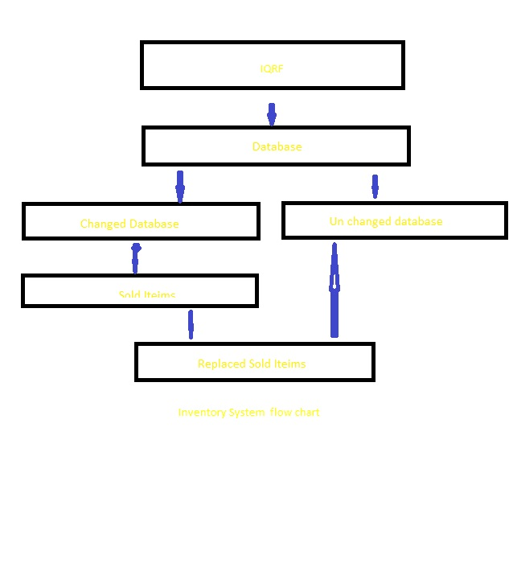

**Citations**

* <http://www.iqrf.org/iqrfabout/case-studies/automated-inventory-system>
* [www.yahoo.com](http://www.yahoo.com)
* [www.bing.com](http://www.bing.com)

